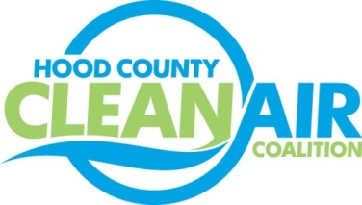
Meeting: Wednesday, August 3, 2016
Neely House
304 East Rucker Street, Granbury, Texas 76048
8:30-10:00 a.m.

Agenda

- Call Meeting to Order
- EPA Updates – Randy Pitre
- Regional Updates – Michelle McKenzie
  - Air Quality Funding Opportunities for Vehicles
  - Upcoming Trainings (Information at http://www.dfwcleancities.org/cals/default.asp)
    - CNG Fuel System Inspector Training August 2-3
    - CNG Fueling Safety and Inspection Training, September 6-7
    - National Drive Electric Week Event, September 17
    - CNG Fuel System Inspector Training, October 4-5
  - TCEQ Meeting August 3 on Proposed 2015 Ozone Nonattainment Designations; https://www.tceq.texas.gov/airquality/sip/eighthour.html
- Local Updates – Michelle McKenzie
  - Review of May, June and July Meeting Summaries
  - Review of Projects
    - Monthly Budget Review for April, May, and June
    - Status of Projects FY 16/17
  - Reports
    - July Ozone Update
    - Solar Webinars
    - DFW Clean Cities Meeting
    - Air North Texas Meeting
    - Regional Ozone Advance/ Nonattainment Area Meeting
  - 2016 Hood County Update for Ozone Advance
5.) Discussion
6.) Adjourn

